Donating to MAPS via Paypal.com using an
Android Device

Step 1: Download the PayPal app and create an account. Connect the app to your debit, credit card, or bank account. Once you enter the information and can open the app, click SEND at the bottom of the screen.
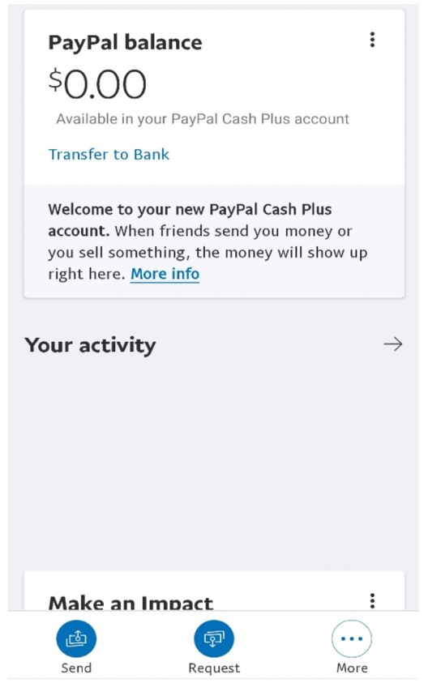

Step 2 and 3: Enter the email address maps4families@gmail.com
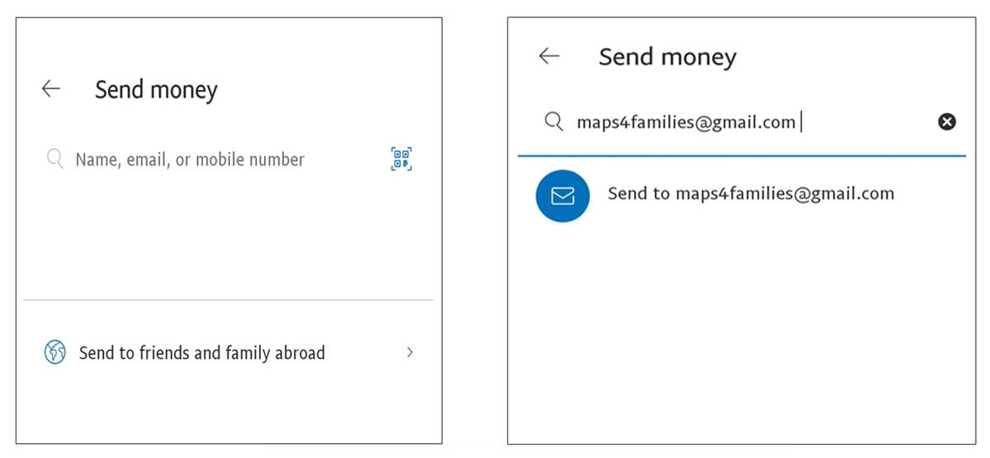

Step 4 and 5: IMPORTANT: Enter $5.00 and then in the ADD A MESSAGE FIELD, put your (Representative’s information Your Name, Death Notice Number, and today’s Date), then click NEXT.
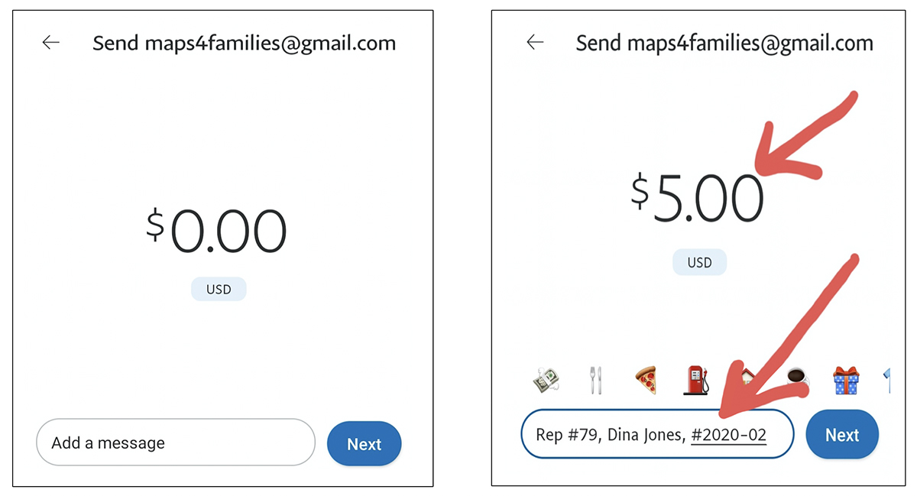

Step 6: Click on “Friends and Family” (you should have a check mark), then click “Next.”
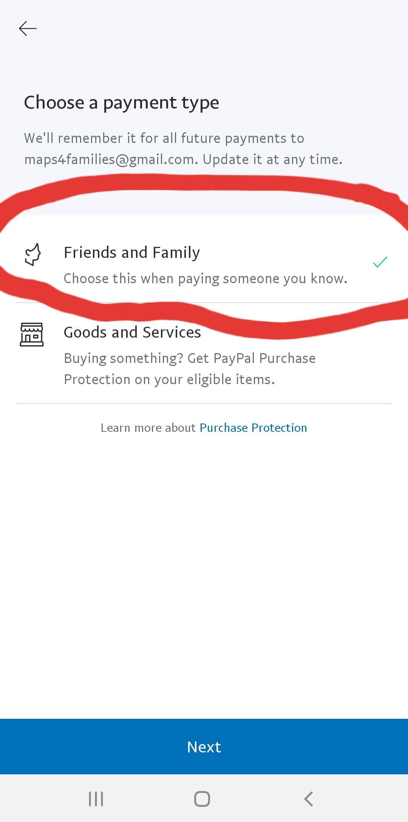
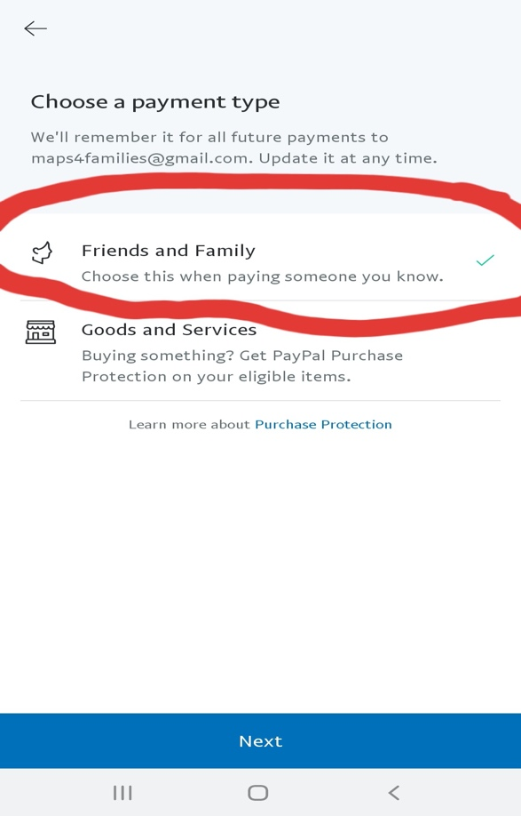

Step 7 and 8: If everything looks correct, click “Send now” and then, “Done.”
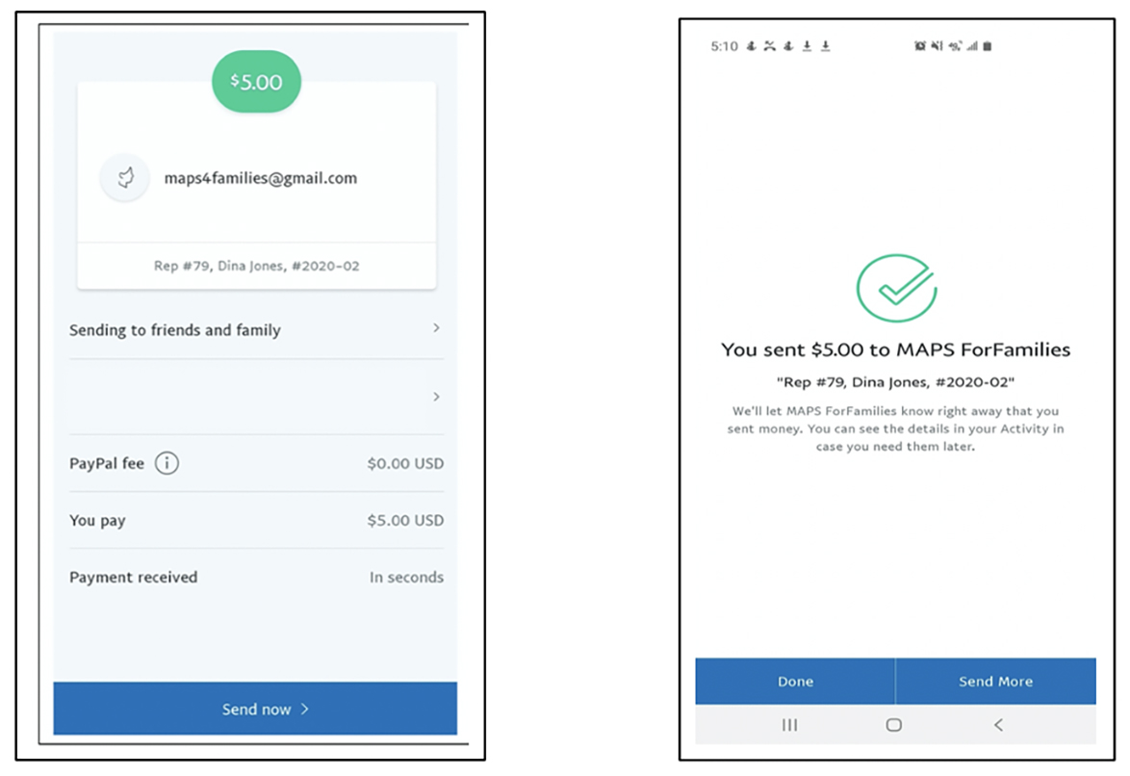

Step 9: PayPal will send you a message if you set it up to do so.

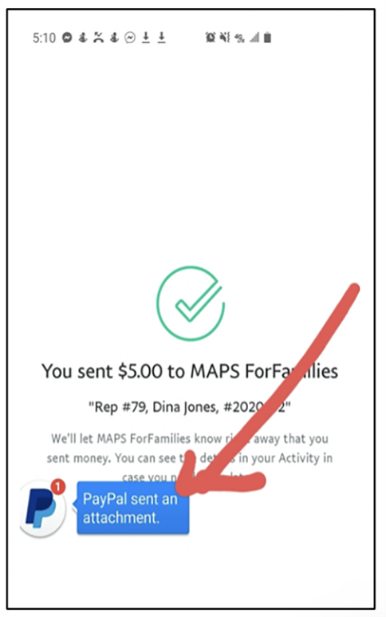

Step 10:
Depending upon how you set up your application, PayPal will send you a confirmation of payment.

Step 11: Upon receiving email confirmation from PayPal, please send your email receipt to: your MAPS representative & Jacquita.Parker@faa.gov

